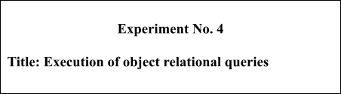

Batch: B3 Roll No.: 16010422230 Experiment No.:4 Title: Execution of object relational queries

Resources needed: PostgreSQL 9.3

Theory

Object types are user-defined types that make it possible to model real-world entities such as customers and purchase orders as objects in the database.

New object types can be created from any built-in database types and any previously created object types, object references, and collection types. Metadata for user-defined types is stored in a schema that is available to SQL, PL/SQL, Java, and other published interfaces.

Row Objects and Column Objects:
Objects that are stored in complete rows in object tables are called row objects. Objects that are stored as columns of a table in a larger row, or are attributes of other objects, are called column objects

Defining Types:

In PostgreSQL the syntax for creating simple type is as follows,

CREATE TYPE name AS
( attribute_name data_type [, ... ] );

Example:

A definition of a point type consisting of two numbers in PostgreSQL is as follows,

create type PointType as( x int,
- int
);

An object type can be used like any other type in further declarations of object-types or table-types.
E.g. a new type with name LineType is created using PointType which is created earlier.

CREATE TYPE LineType AS(
end1 PointType, end2 PointType
);

Dropping Types :

To drop type for example LineType, command will be :

DROP TYPE Linetype;

Constructing Object Values:

Like C++, PostgreSQL provides built-in constructors for values of a declared type, and these constructors can be invoked using a parenthesized list of appropriate values.
For example, here is how we would insert into Lines a line with ID 27 that ran from the origin to the point (3,4):
INSERT INTO Lines VALUES(27,((0,0),(3,4)),distance(0,0,3,4));

Declaring and Defining Methods:
A type declaration can also include methods that are defined on values of that type. The method is declared as shown in example below.
CREATE OR REPLACE FUNCTION distance(x1 integer, y1 integer,x2 integer,y2 integer) RETURNS float AS $$
BEGIN
RETURN sqrt(power((x2-x1),2)+power((y2-y1),2));
END;
$$ LANGUAGE plpgsql;

Then you can create tables using these object types and basic datatypes. Creation on new table Lines is shown below.
CREATE TABLE Lines (
lineID INT, line LineType, dist float
);

Now after the table is created you can add populate table by executing insert queries as explained above.

You can execute different queries on Lines table. For example to display data of Lines table, select specific line from Lines table etc.

Queries to Relations That Involve User-Defined Types:

Values of components of an object are accessed with the dot notation. We actually saw an example of this notation above, as we found the x-component of point end1 by referring to end1.x, and so on. In general, if N refers to some object O of type T, and one of the components (attribute or method) of type T is A, then N.A refers to this component of object O.

For example, the following query finds the x co-ordinates of both endpoints of line.

SELECT lineID, ((L.line).end1).x,((L.line).end2).x FROM Lines L;

- Note that in order to access fields of an object, we have to start with an alias of a relation name. While lineID, being a top-level attribute of relation Lines, can be referred to normally, in order to get into the attribute line, we need to give relation Lines an alias (we chose L) and use it to start all paths to the desired subobjects.
- Dropping the ``L'' or replacing it by ``Lines.'' doesn't work.
- Notice also the use of a method in a query. Since line is an attribute of type LineType, one can apply to it the methods of that type, using the dot notation shown.

Here are some other queries about the relation lines.

SELECT (L.line).end2 FROM Lines L;

Prints the second end of each line, but as a value of type PointType, not as a pair of numbers.

Object Oriented features:
Inheritance:
CREATE TABLE point of PointType; CREATE TABLE axis (
- int
) inherits (point);

INSERT INTO axis values(2,5,6); select * from axis;

Procedure / Approach /Algorithm / Activity Diagram:
Perform following tasks,
- Create a table using object type field
- Insert values in that table
- Retrieve values from the table
- Implement and use any function associated with the table created

Results: (Queries depicting the above said activity performed individually) USE COURIER NEW FONT WITH SIZE =11 FOR QUERY STATEMENTS TASK 1 -
CREATE TYPE book_price AS
(
currency_code VARCHAR(3),
amount NUMERIC(10, 2)
);

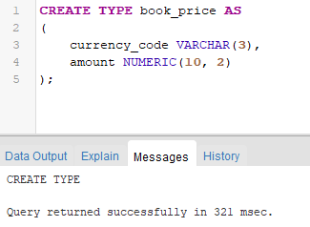

TASK 2 -

CREATE TABLE story_books ( book_id SERIAL PRIMARY KEY,
book_name VARCHAR(255), book_description TEXT, price book_price, quantity INTEGER,author_name TEXT
);

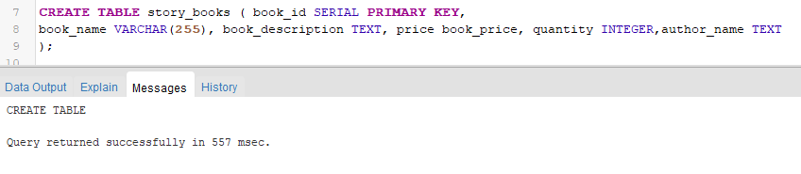

INSERT INTO story_books (book_name, book_description, price, quantity,author_name)
VALUES
('Harry Potter', 'Fiction', ROW('USD', 5.99), 1,'J.K. Rowling'),
('Things We Never Got Over', 'Love Story', ROW('EUR', 4.50), 1,'Lucy Score'),
('Good Girls Guide To Murder', 'Suspense', ROW('GBP', 6.99), 1,'Holly Jackson');

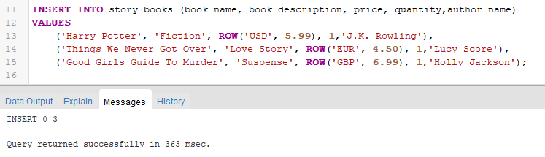

TASK 3 -

SELECT * FROM story_books;

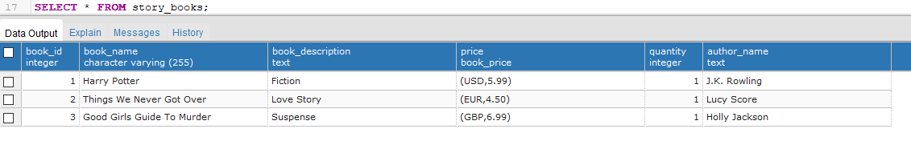

TASK 4 -

CREATE OR REPLACE FUNCTION calculate_total_value() RETURNS book_price AS $$
DECLARE
total_value book_price; BEGIN
SELECT book_price(price.currency_code, SUM(price.amount * quantity))
INTO total_value
FROM story_books;

RETURN COALESCE(total_value, ROW('', 0.00)::book_price);
END;
$$ LANGUAGE plpgsql;

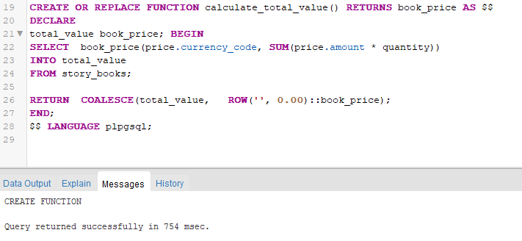

Questions:

1. What is the difference between object relational and object oriented databases?

Answer: Object-relational databases (ORDBMS) and object-oriented databases (OODBMS) are two different approaches to database management, each with its own set of characteristics. Here are the key differences between them:

- Data Model:
- Object-Relational Databases (ORDBMS): ORDBMS combines elements of both relational databases and object-oriented databases. It extends the relational model to include
object-oriented features, such as complex data types, inheritance, and encapsulation.
- Object-Oriented Databases (OODBMS): OODBMS is based on the principles of object-oriented programming. It directly supports the storage and manipulation of objects, allowing for the representation of complex data structures and relationships.

- Data Structure:
- ORDBMS: Data is typically organized in tables (relations) with rows and columns, similar to traditional relational databases. However, ORDBMS introduces support for complex data types, like arrays, structs, or user-defined types, which go beyond the basic scalar types of traditional databases.
- OODBMS: Data is represented as objects, which can encapsulate both data and behavior (methods). Objects can have attributes and methods, making it a more natural fit for modeling real-world entities and their interactions.

- Query Language:
- ORDBMS: Uses SQL (Structured Query Language) as the query language, with extensions to support object-oriented features.
- OODBMS: Typically uses a query language specifically designed for navigating and manipulating objects. Examples include OQL (Object Query Language) and others.

- Inheritance:
- ORDBMS: Inheritance is not a native concept in traditional relational databases. However, some ORDBMS implementations introduce limited support for inheritance through features like table inheritance.
- OODBMS: Fully supports the concept of inheritance, allowing objects to inherit attributes and behaviors from other objects.

- Schema Design:
- ORDBMS: Schema design is similar to traditional relational databases, with tables, columns, and relationships. Additional features, such as user-defined types, can be used to model more complex structures.
- OODBMS:Emphasizes the design of classes and objects. Relationships between objects are often modeled directly in the class hierarchy.

- Performance:
- ORDBMS: Generally performs well for traditional relational data models. The additional features may introduce some overhead, but optimizations are often in place to mitigate this.
- OODBMS: Performance can be efficient for scenarios where complex relationships and behaviors are central. However, it may face challenges in scenarios where traditional relational databases excel.

Give comparison of any two database systems providing object relational database features.

Answer: Let's compare two popular database systems that provide object-relational database features: PostgreSQL and Oracle Database.

- Licensing: PostgreSQL is open source and free to use, whereas Oracle Database is a commercial product, and users typically need to pay for licenses.
- Cost: PostgreSQL is often chosen for cost considerations, especially for smaller projects or startups. Oracle Database is generally used in large enterprise environments that require extensive features and support.
- Community and Ecosystem: PostgreSQL has a strong and active open-source community. Oracle Database has a large user base and extensive support from Oracle Corporation.
- Performance: Performance can depend on specific use cases and configurations. Both databases have optimizations for high-performance scenarios.
- Scalability: Both PostgreSQL and Oracle Database are scalable, but Oracle is often associated with large-scale enterprise applications with demanding scalability requirements.
- Ease of Use: PostgreSQL is known for its simplicity and ease of use, especially for developers familiar with standard SQL. Oracle Database may have a steeper learning curve due to its extensive feature set.

Explore how the user defined types can be modified with queries.

Answer: In relational databases, user-defined types (UDTs) allow users to define custom data types according to their specific requirements. The ability to modify UDTs with queries can vary depending on the database management system (DBMS) being used. Below, I'll provide a general overview of how you might modify user-defined types using SQL queries.

Assuming you have a user-defined type named `my_custom_type`, here's how you might modify it using SQL queries:

- Adding a New Attribute to the UDT:

ALTER TYPE my_custom_type
ADD ATTRIBUTE new_attribute_name data_type;

This query adds a new attribute to the existing user-defined type. You need to specify the name of the new attribute and its data type.

- Dropping an Attribute from the UDT:

ALTER TYPE my_custom_type DROP ATTRIBUTE attribute_name;

This query removes an attribute from the user-defined type. Replace `attribute_name` with the name of the attribute you want to remove.

- Modifying the Data Type of an Attribute:

ALTER TYPE my_custom_type

ALTER ATTRIBUTE attribute_name SET DATA TYPE new_data_type;

Use this query if you need to change the data type of an existing attribute. Specify the attribute name and the new data type.

- Renaming the UDT:

ALTER TYPE old_type_name RENAME TO new_type_name;

You can rename the user-defined type using this query. Replace `old_type_name` with the current name and `new_type_name` with the desired new name.

- Modifying Constraints or Defaults:

ALTER TYPE my_custom_type
ALTER ATTRIBUTE attribute_name SET DEFAULT default_value;

ALTER TYPE my_custom_type
ALTER ATTRIBUTE attribute_name DROP DEFAULT;

Outcomes:

Design advanced database systems using Object relational, Spatial and NOSQL databases and its implementation.

Conclusion: (Conclusion to be based on the objectives and outcomes achieved)

We learned the execution of object relational queries.

Grade: AA / AB / BB / BC / CC / CD /DD Signature of faculty in-charge with date

References:

  - Elmasri and Navathe, “Fundamentals of Database Systems”, Pearson Education
  - Raghu Ramakrishnan and Johannes Gehrke, “Database Management Systems” 3rd Edition, McGraw Hill,2002
  - Korth, Silberchatz, Sudarshan, “Database System Concepts” McGraw Hill

